--OBJECTIVES QUESTIONS:
Q1. List the different dtypes of columns in table “ball_by_ball” (using information schema)
Ans. Use the below query to get the dtypes of columns in table “ball_by_ball” and there is total 11 columns with int datatype in the table “ball_by_ball”.
Query:
SELECT COLUMN_NAME,DATA_TYPE
FROM INFORMATION_SCHEMA.COLUMNS
WHERE TABLE_NAME="ball_by_ball";
Output:
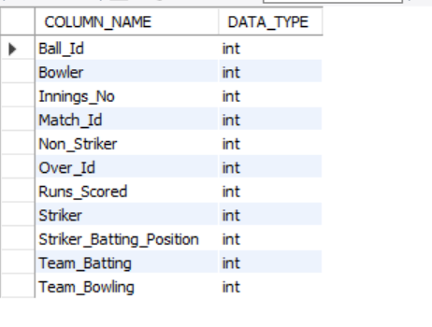
Q2. What is the total number of runs scored in 1st season by RCB (bonus: also include the extra runs using the extra runs table)
Ans. To find the total runs scored by Royal Challengers Bangalore (RCB) in the first IPL season, including extra runs, the following tables are needed:
Required Tables:
- matches: Contains match details, including the teams and season. team: Provides team names and IDs.
- ball_by_ball: Tracks each ball bowled, including the team batting.
- extra_runs: Tracks additional runs like wides and no-balls.
Query Approach:
- Match Selection: Filters matches where RCB played (Team_Id = 2) in the first season.
- Joining Tables: Joins relevant tables to link matches, balls, runs scored, and extra runs.
- Sum Runs: Adds up runs scored by RCB's batsmen and any extra runs.

Query:
Select sum(b.Runs_Scored + coalesce(e.Extra_Runs, 0)) AS Total_Runs
from ball_by_ball b
join matches m on b.Match_Id = m.Match_Id
join team t on b.Team_Batting = t.Team_Id
left join extra_runs e ON b.Match_Id = e.Match_Id
and b.Over_Id = e.Over_Id
and b.Ball_Id = e.Ball_Id
and b.Innings_No = e.Innings_No
where m.Season_Id = 6
and t.Team_Name = "Royal Challengers Bangalore";
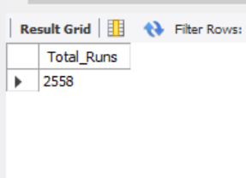

-- Q3. How many players were more than the age of 25 during season 2014?
Ans. 89
Tables Required:
- player - To get the player's date of birth.
- player_match - To find which players participated in matches during season 2014.
- matches - To find matches in season 2014.
- season - To identify season 2014 and its matches.
Query Approach: This query calculates the number of unique players whose age was above 25 during the 2014 season. To achieve this:
- Join the player, player_match, and matches tables: This allows access to the player's date of birth.
- Filter by season: The matches table is restricted to only those that belong to the 2014 season by matching the season ID for the year 2014 from the season table.
- Age Calculation: The TIMESTAMPDIFF function computes the player's age at the time of each match. Only records where the player's age exceeds 25 on the date ‘2014-01-01’ are considered.
- Count Unique Players: The query counts distinct player IDs who meet the criteria above, giving the total number of players above 25 years of age during the 2014 season.
Query:
SELECT
COUNT(DISTINCT p.player_id) as Total_player_above25
FROM
player p
INNER JOIN player_match pm ON p.player_id = pm.player_id
INNER JOIN matches m ON m.match_id = pm.match_id
WHERE TIMESTAMPDIFF(YEAR,p.dob,'2014-01-01') >25
AND m.season_id = (SELECT season_id FROM season
WHERE season_year='2014');
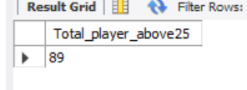

Q4. How many matches did RCB win in 2013?
Ans. Approach:To find the matches played by RCB in 2013
RCB won 9 matches in the 2013 season, and this result is obtained by counting all rows in the matches table where Royal Challengers Bangalore is recorded as the match winner. The condition Match_Winner = 2 filters the data to include only RCB’s victories using the team’s unique identifier, while YEAR(Match_Date) = 2013 restricts the calculation to matches played during the 2013 season, ensuring the final count accurately reflects RCB’s wins for that year.

Query:
SELECT COUNT(*) AS TOTAL_WIN_BY_RCB_2013
FROM matches
WHERE Match_Winner=2 AND YEAR(Match_Date)=2013;
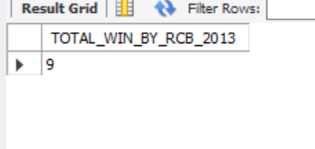
-- Q5. List the top 10 players according to their strike rate in the last 4 seasons
ANS : Approach: This query identifies these players by aggregating ball-level data from the ball_by_ball table and linking it with matches and season to restrict the analysis to the most recent four seasons based on season year. It then joins with the player table to map striker IDs to player names and calculates each player’s strike rate as total runs scored per 100 balls faced. By grouping at the player level and ordering the results in descending strike rate, the query highlights the most explosive batsmen over the last four seasons and returns the top ten performers.
QUERY:
Select p.Player_Name, sum(b1.Runs_Scored) as Total_Run, count(*) as Balls_Faced,
round(sum(b1.Runs_Scored) * 100.0 / count(*), 2) as Strike_Rate
from ball_by_ball b1
join matches m on b1.Match_Id = m.Match_Id
join season s on m.Season_Id = s.Season_Id
join player p on b1.Striker = p.Player_Id
where s.Season_Year >= (select max(Season_Year) - 3 from season)
group by p.Player_Name
order by Strike_Rate desc limit 10;
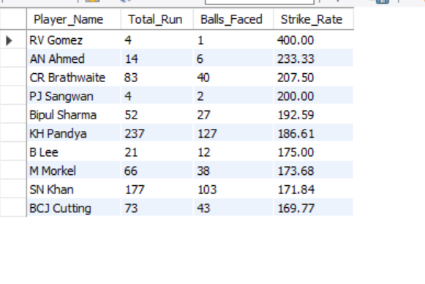
-- Q6. What are the average runs scored by each batsman considering all the seasons?
Ans:Approach: This query computes the average runs scored by each batsman across all IPL seasons. It joins the ball_by_ball table with the player table to associate every delivery with the correct batsman and then aggregates performance at the player level. Total runs are calculated using SUM(Runs_Scored), while the number of innings played is approximated by counting distinct matches in which the player batted. The batting average is derived by dividing total runs by innings played and rounding the result for clarity. Finally, the results are ordered by batting average in descending order to highlight the most consistent run-scorers.
Query:
-- SELECT p.Player_Name, SUM(Runs_Scored) AS Total_Runs,
-- COUNT(DISTINCT Match_ID) AS Innings_Played,
-- ROUND(SUM(Runs_Scored)/COUNT(DISTINCT Match_ID),2) AS BATTING_AVERAGE
-- FROM ball_by_ball b
-- JOIN player p
-- ON b.Striker=p.Player_ID
-- GROUP BY Player_Name
-- ORDER BY BATTING_AVERAGE DESC;
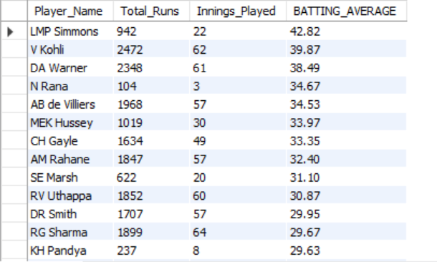

-- Q7. What are the average wickets taken by each bowler considering all the seasons
Ans. The average wickets taken by each bolwer in all season are as follows:
Approach: Join the player table with ball_by_ball on bowler's player_id,Join ball_by_ball with wicket_taken on match_id, over_id, and ball_id to identify wickets taken by each bowler.
Join ball_by_ball (or wicket_taken) with matches on match_id to access season information.Group data by player name.Calculate total wickets by counting player_out entries.
Calculate the number of distinct seasons bowled by counting unique season_ids.
Compute average wickets per season by dividing total wickets by number of seasons.
Order results by average wickets in descending order.

Query:
SELECT
p.player_name,
COUNT(wt.player_out) / COUNT(DISTINCT m.season_id) AS avg_wickets_per_season
FROM
player p
JOIN
ball_by_ball b ON b.bowler = p.player_id
JOIN
wicket_taken wt ON wt.match_id = b.match_id AND wt.over_id = b.over_id AND wt.ball_id = b.ball_id
JOIN
matches m ON m.match_id = b.match_id
GROUP BY
p.player_name
ORDER BY
avg_wickets_per_season DESC;

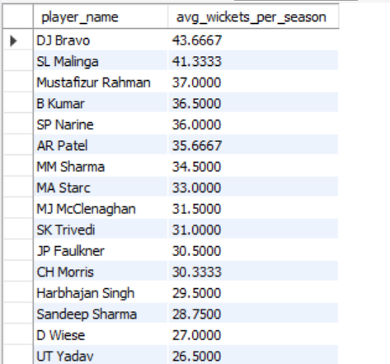

-- Q8. List all the players who have average runs scored greater than the overall average and who have taken wickets greater than the overall average.

Ans: Approach: This query identifies true all-round performers who excel in both batting and bowling compared to the overall dataset. It first computes each player’s total runs and derives a batting average based on dismissals, ensuring players with no outs are handled safely. In parallel, it calculates bowling performance by counting valid wickets taken by each bowler using precise ball-level joins and filtering non-bowling dismissals. The overall average batting and wicket benchmarks are then computed across all players. Finally, only those players whose batting average and wicket count both exceed the overall averages are selected, highlighting players who consistently outperform the league in both disciplines.
Query:
with playerbattingstats as (
select p.player_id, p.player_name, sum(bbb.runs_scored) as total_runs_scored
from ball_by_ball bbb
join player p on bbb.striker = p.player_id
group by p.player_id, p.player_name),
playerdismissals as (
select wt.player_out as player_id, count(*) as total_times_out
from wicket_taken wt
group by wt.player_out),
playerbattingaverage as (
select s.player_id, s.player_name,
case when coalesce(d.total_times_out,0) = 0 then null
else (s.total_runs_scored) / d.total_times_out end as batting_avg
from playerbattingstats s
left join playerdismissals d on s.player_id = d.player_id),
playerbowlingstats as (
select bb.bowler as player_id, count(*) as total_wickets
from wicket_taken wt
join ball_by_ball bb
on bb.match_id = wt.match_id
and bb.innings_no = wt.innings_no
and bb.over_id = wt.over_id
and bb.ball_id = wt.ball_id
join out_type ot on ot.out_id = wt.kind_out
where ot.out_name not in ('caught','run out ','retired hurt','stumped','obstructing the field')
group by bb.bowler),
overall as (
select
(select avg(batting_avg) from playerbattingaverage) as overall_batting_avg,
(select avg(total_wickets) from playerbowlingstats) as overall_wickets_avg
)
select
pba.player_id,
pba.player_name,
round(pba.batting_avg, 2) as batting_avg,
pbs.total_wickets,
round(o.overall_batting_avg, 2) as overall_batting_avg,
round(o.overall_wickets_avg, 2) as overall_wickets_avg
from playerbattingaverage pba
join playerbowlingstats pbs on pba.player_id = pbs.player_id
cross join overall o
where pba.batting_avg > o.overall_batting_avg
and pbs.total_wickets > o.overall_wickets_avg
order by pba.batting_avg desc, pbs.total_wickets desc;
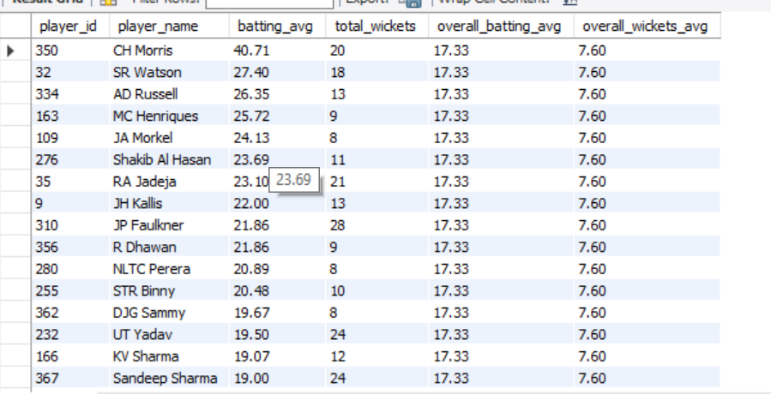
- Q9. Create a table rcb_record table that shows the wins and losses of RCB in an individual venue.
Ans: Approach:This query creates and populates an rcb_record table that summarizes Royal Challengers Bangalore’s performance at each venue. The solution is implemented in two stages to clearly separate structure from logic. First, a new table named rcb_record is created to store venue-wise performance, defining columns for venue ID, venue name, and counters for wins and losses. In the second stage, the table is populated by selecting match data where RCB participated, joining the matches table with the venue table to associate each match with its venue. Conditional aggregation is then applied to count a win when RCB is recorded as the match winner and a loss for all other outcomes. By grouping the results by venue, the final table provides a concise and accurate summary of RCB’s wins and losses at each ground.
Query:
create table rcb_records (
Venue_Id int not null,
Venue_Name varchar(450) not null,
Wins int default 0,
Losses int default 0,
primary key (Venue_Id));
insert into rcb_record (Venue_Id, Venue_Name, Wins, Losses)
select v.Venue_Id, v.Venue_Name,
count(case when m.Match_Winner = 1 then 1 else null end) As Wins,
count(case when m.Match_Winner != 1 then 1 else null end) As Losses
from matches m
join Venue v ON m.Venue_Id = v.Venue_Id
where (m.Team_1 = 1 or m.Team_2 = 1)
group by v.Venue_Id, v.Venue_Name;
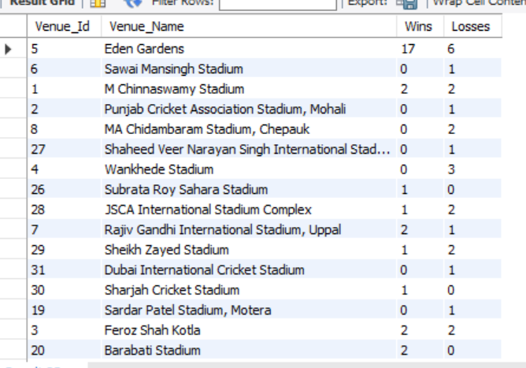
-- Q10. What is the impact of bowling style on wickets taken?
Ans: Approach:The query measures the impact of bowling style on wickets by first linking each wicket to the exact delivery using match, innings, over, and ball identifiers from the ball_by_ball and wicket_taken tables. It then maps each bowler to their bowling style through the player and bowling_style tables, ensuring every dismissal is correctly attributed to a specific style. Finally, the data is grouped by bowling style and the number of players dismissed is counted, allowing a clear comparison of how different bowling styles contribute to overall wicket-taking across all matches. The analysis shows that right-arm medium bowlers take the most wickets (617), followed by right-arm fast-medium (382) and right-arm medium-fast (343), while among spinners right-arm offbreak (290) and slow left-arm orthodox (283) are the most effective, indicating strong wicket-taking impact from both controlled pace and spin bowling styles.
Query:
select bs.Bowling_skill, count(wt.Player_Out) as Wicket_taken
from ball_by_ball as bb
join wicket_taken as wt on bb.Match_Id = wt.Match_Id
and bb.Innings_No = wt.Innings_No
and bb.Over_Id = wt.Over_Id and bb.Ball_Id = wt.Ball_Id
join player as p on bb.Bowler = p.Player_Id
join bowling_style as bs on p.Bowling_skill = bs.Bowling_Id
group by bs.Bowling_skill;

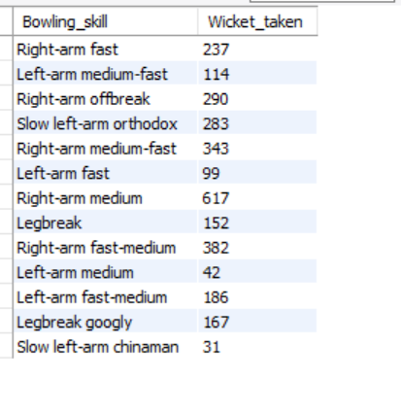

-- Q11. Write the SQL query to provide a status of whether the performance of the team is better than the previous year's performance on the basis of the number of runs scored by the team in the season and the number of wickets taken
Ans:Approach: Aggregate total runs per team per season.Aggregate total wickets per team per season.Combine both to get team performance per season.Use LAG() to get the previous year’s performance for the same team.Compare current vs. previous to determine if the team improved, declined, or stayed the same.

Query:
with team_runs as (select m.Season_Id, b.Team_Batting AS Team_Id, sum(b.Runs_Scored) as Total_Runs
from Ball_by_Ball b
join Matches m on b.Match_Id = m.Match_Id
group by m.Season_Id, b.Team_Batting),

team_wickets as (select m.Season_Id, b.Team_Bowling AS Team_Id, count(w.Player_Out) as Total_Wickets
from Ball_by_Ball b
join Matches m ON b.Match_Id = m.Match_Id
join Wicket_Taken w on b.Match_Id = w.Match_Id
and b.Over_Id = w.Over_Id
and b.Ball_Id = w.Ball_Id
and b.Innings_No = w.Innings_No
group by m.Season_Id, b.Team_Bowling),

combined as (select r.Season_Id, r.Team_Id, r.Total_Runs, w.Total_Wickets
from team_runs r
join team_wickets w on r.Season_Id = w.Season_Id and r.Team_Id = w.Team_Id),

with_previous as (
select c.*, s.Season_Year, lag(c.Total_Runs) over (partition by c.Team_Id order by s.Season_Year) as Prev_Total_Runs,
lag(c.Total_Wickets) over (partition by c.Team_Id order by s.Season_Year) as Prev_Total_Wickets
from combined c
join Season s on c.Season_Id = s.Season_Id)

select t.Team_Name, wp.Season_Year, wp.Total_Runs, wp.Total_Wickets, wp.Prev_Total_Runs, wp.Prev_Total_Wickets,
CASE
when wp.Total_Runs > wp.Prev_Total_Runs and wp.Total_Wickets > wp.Prev_Total_Wickets then 'Better'
when wp.Total_Runs < wp.Prev_Total_Runs and wp.Total_Wickets < wp.Prev_Total_Wickets then 'Worse'
else 'Same'
end as Performance_Status
from with_previous wp
join Team t on wp.Team_Id = t.Team_Id
where wp.Prev_Total_Runs is not null and wp.Prev_Total_Wickets is not null
order by t.Team_Name, wp.Season_Year;
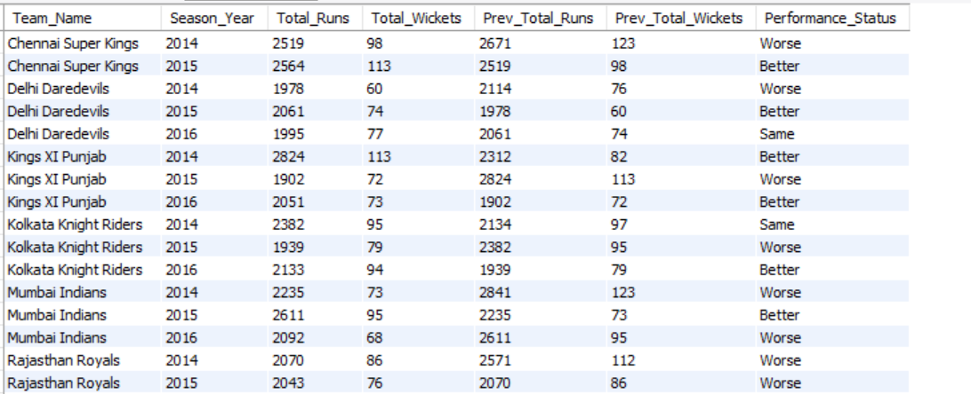

-- -- Q12. Can you derive more KPIs for the team strategy?

-- 1. Win Percentage:
Ans:Use the Matches table, filter by team as MatchWinner, and divide the number of wins by matches played.
Query:
SELECT
t.team_name,
COUNT(CASE WHEN m.match_winner = t.team_id THEN 1 END) * 100.0 / COUNT(*) AS win_percentage
FROM
matches m
JOIN
team t ON t.team_id = m.team_1 OR t.team_id = m.team_2
GROUP BY
t.team_name;
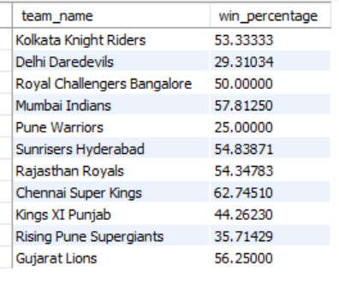
-- -- 2.Average Runs per Match
Ans:
- Join the ball_by_ball, matches, and team tables to relate runs scored to the team and match context.
- Filter/group by batting team to sum up runs for each team.
- Count unique matches played (using COUNT(DISTINCT m.match_id)) to get matches per team.
- Divide total runs by total matches to calculate the average per team.
Query:
SELECT t.team_name,
SUM(b.runs_scored) / COUNT(DISTINCT m.match_id) AS avg_runs_per_match
FROM
ball_by_ball b
JOIN
matches m ON b.match_id = m.match_id
JOIN
team t ON b.team_batting = t.team_id
GROUP BY
t.team_name
ORDER BY
avg_runs_per_match DESC;
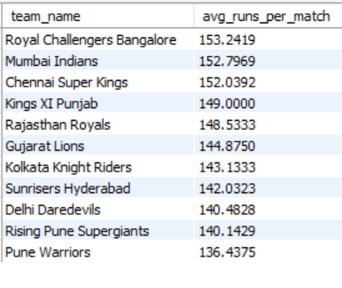
-- -- 3. Average Wickets per Match
Ans:
- Ans: Join wicket_taken with ball_by_ball to relate each wicket to the team bowling that ball.
- Join matches to associate matches context.
- Join team on bowling team for readable output.
- Count total wickets using the player_out column in wicket_taken for each team.
- Count unique matches bowled by each team.
- Divide total wickets by total matches to get average wickets per match.

Query:
SELECT
t.team_name,
COUNT(w.player_out) / COUNT(DISTINCT m.match_id) AS avg_wickets_per_match
FROM
wicket_taken w
JOIN
ball_by_ball b ON w.match_id = b.match_id AND w.over_id = b.over_id AND w.ball_id = b.ball_id
JOIN
matches m ON w.match_id = m.match_id
JOIN
team t ON b.team_bowling = t.team_id
GROUP BY
t.team_name
ORDER BY
avg_wickets_per_match DESC;

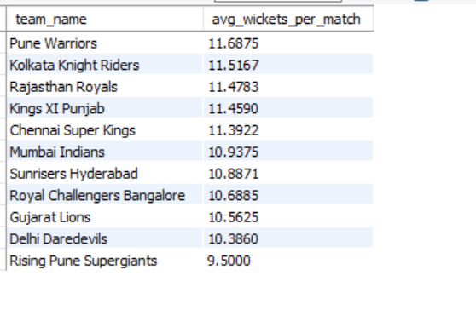
-- -- 4. Run Rate
Ans: Join ball_by_ball and team to relate runs to teams. Sum runs scored for each team.Count all balls faced .Divide runs by overs to get overall run rate for each team. Count matches if differentiating between average per match and total run rate.

Query:
SELECT
t.team_name,
SUM(b.runs_scored) / (COUNT(DISTINCT m.match_id) * 20) AS run_rate
FROM
ball_by_ball b
JOIN
matches m ON b.match_id = m.match_id
JOIN
team t ON b.team_batting = t.team_id
GROUP BY
t.team_name
ORDER BY
run_rate DESC;

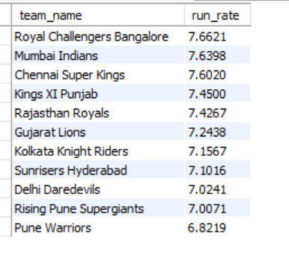
-- -- 5.Toss Impact KPI
Ans: Join matches and team on the toss winner to get readable team names.Join matches and toss_decision on the toss_decide column to get the toss decision name.Group by team and toss decision to separate results for each decision per team.Calculate win percentage using a conditional count where toss winner is also match winner, divided by total matches for that toss decision.
Order by team and toss decision for clear output.
Query:
SELECT
t.team_name,
td.toss_name AS toss_decision,
COUNT(CASE WHEN m.toss_winner = m.match_winner THEN 1 END) * 100.0 / COUNT(*) AS win_percentage_after_toss_decision
FROM
matches m
JOIN
team t ON m.toss_winner = t.team_id
JOIN
toss_decision td ON m.toss_decide = td.toss_id
GROUP BY
t.team_name, td.toss_name
ORDER BY
t.team_name, td.toss_name;

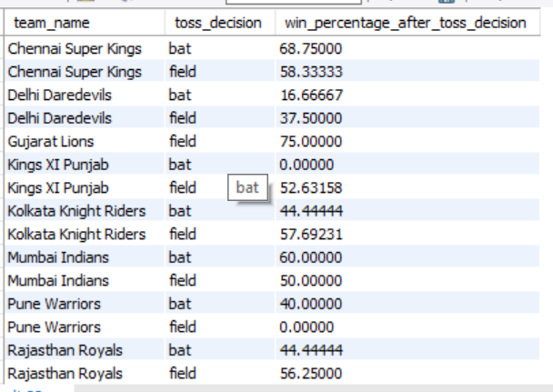

-- -- Q13. Using SQL, write a query to find out the average wickets taken by each bowler in each venue. Also, rank the gender according to the average value.
Ans: Approach: This query calculates the average wickets taken by each bowler at each venue and then ranks them based on that average. It first joins ball_by_ball with wicket_taken at the exact delivery level to ensure every wicket is correctly attributed to the bowler who took it. The query then links match and venue information so that wickets are analyzed venue-wise, and divides the total wickets by the number of distinct matches played at that venue to compute the average wickets per match. Using a window function (ROW_NUMBER), bowlers are ranked in descending order of their average wickets, making it easy to identify which bowlers are most effective at specific venues based on their average wicket-taking performance.
Query:
with Bowler_Avg_Wickets as (select p.Player_Id, p.Player_Name, v.Venue_Name,
count(wt.Player_Out) / count(distinct m.Match_Id) as Avg_Wickets
from ball_by_ball bb
join wicket_taken wt on bb.Match_Id = wt.Match_Id
and bb.Innings_No = wt.Innings_No
and bb.Over_Id = wt.Over_Id
and bb.Ball_Id = wt.Ball_Id
join player p on bb.Bowler = p.Player_Id
join matches m on bb.Match_Id = m.Match_Id
join venue v on m.Venue_Id = v.Venue_Id
group by p.Player_Id, p.Player_Name, v.Venue_Name)
select Player_Id, Player_Name, Venue_Name, Avg_Wickets,
row_number() over (order by Avg_Wickets desc) as Wicket_Rank
from Bowler_Avg_Wickets
order by Wicket_Rank;
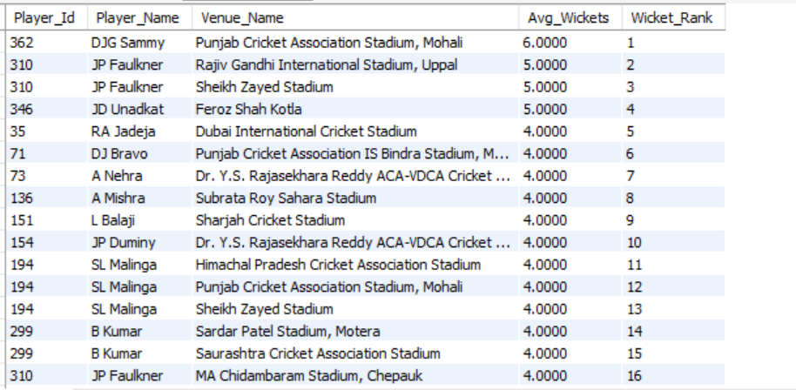
-- Q14. Which of the given players have consistently performed well in past seasons? (will you use any visualization to solve the problem)
Ans: Approach:This analysis measures consistency by identifying seasons in which players crossed high performance thresholds—more than 400 runs for batting or more than 15 wickets for bowling. Separate CTEs first calculate season-wise batting runs and bowling wickets for each player. These results are then combined to capture both batting and bowling contributions, and the number of distinct seasons with such strong performances is counted per player. Players appearing in at least three seasons are classified as consistent performers. A simple bar chart or line trend visualization of performance across seasons could further help validate and communicate this consistency clearly. The results show that DA Warner is the most consistent performer with strong performances in 4 seasons, followed by V Kohli, RG Sharma, DJ Bravo, AM Rahane, SL Malinga, B Kumar, and MM Sharma, each delivering standout performances in 3 different seasons, indicating sustained impact over multiple years.

Query:
WITH Batting as (select p.Player_Id, p.Player_Name, s.Season_Year, sum(b.Runs_Scored) as Total_Runs
from Ball_by_Ball b
join Matches m on b.Match_Id = m.Match_Id
join Season s on m.Season_Id = s.Season_Id
join Player p on b.Striker = p.Player_Id
group by p.Player_Id, p.Player_Name, s.Season_Year
order by p.Player_Name, s.Season_Year),

Bowling as (select p.Player_Id, p.Player_Name, s.Season_Year, count(w.Player_Out) as Total_Wickets
from Ball_by_Ball b
join Wicket_Taken w on b.Match_Id = w.Match_Id
and b.Over_Id = w.Over_Id
and b.Ball_Id = w.Ball_Id
and b.Innings_No = w.Innings_No
join Matches m on b.Match_Id = m.Match_Id
join Season s on m.Season_Id = s.Season_Id
join Player p on b.Bowler = p.Player_Id
group by p.Player_Id, p.Player_Name, s.Season_Year
order by p.Player_Name, s.Season_Year)

select b.Player_Id, b.Player_Name, count(distinct b.Season_Year) as best_seasons
from (select Player_Id, Player_Name, Season_Year from Batting where Total_Runs > 400
UNION ALL
select Player_Id, Player_Name, Season_Year from Bowling where Total_Wickets > 15) b
group by b.Player_Id, b.Player_Name
having count(distinct b.Season_Year) >= 3
order by best_seasons desc;
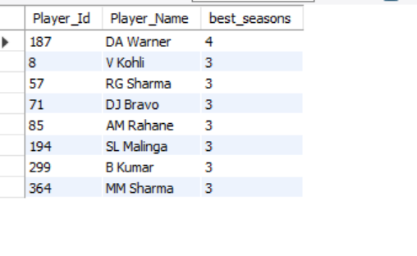
-- Q15. Are there players whose performance is more suited to specific venues or conditions? (how would you present this using charts?)
Ans: There are players whose performance is more suited to specific venues. Some players consistently score more runs or take more wickets at particular grounds due to pitch type, stadium conditions, or home advantage.
-- 1: Write SQL Queries to Get Player-Venue Performance:
-- For Batsman (Runs per Venue):
SELECT
p.Player_Name,
v.Venue_Name,
SUM(b.Runs_Scored) AS Total_Runs
FROM
Ball_by_Ball b
JOIN Matches m ON b.Match_Id = m.Match_Id
JOIN Venue v ON m.Venue_Id = v.Venue_Id
JOIN Player p ON b.Striker = p.Player_Id
GROUP BY
p.Player_Name, v.Venue_Name
Order by Total_Runs desc
Limit 10;
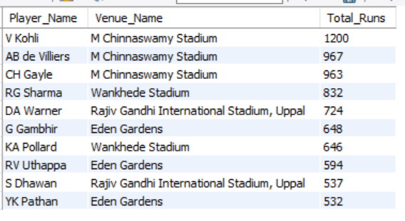

--2. -- For Bowlers (Wickets per Venue):
SELECT
p.Player_Name,
v.Venue_Name,
COUNT(w.Player_Out) AS Total_Wickets
FROM
Ball_by_Ball b
JOIN Wicket_Taken w ON b.Match_Id = w.Match_Id
AND b.Over_Id = w.Over_Id
AND b.Ball_Id = w.Ball_Id
AND b.Innings_No = w.Innings_No
JOIN Matches m ON b.Match_Id = m.Match_Id
JOIN Venue v ON m.Venue_Id = v.Venue_Id
JOIN Player p ON b.Bowler = p.Player_Id
GROUP BY
p.Player_Name, v.Venue_Name
Order by Total_wickets desc
Limit 10;
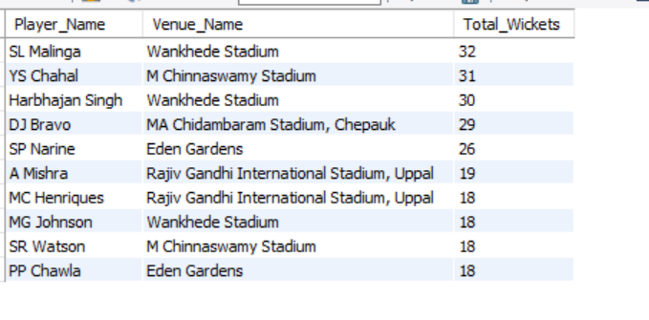

Conclusion:
Yes, there are players whose performance is more suited to specific venues.
I used SQL to fetch venue-wise stats and Excel (pivot table, bar charts) to visualize and compare.
This helped me clearly identify which players are most effective at each stadium.

-- -- Subjective Question

-- Q1. How does the toss decision affect the result of the match? (which visualizations could be used to present your answer better) And is the impact limited to only specific venues?
Ans: To understand how toss decisions have influenced match results, we need to Analyze data from three key tables:

Query:
select v.Venue_Name, td.Toss_Name as Toss_Decision, count(*) as Total_Matches,
sum(case when m.Toss_winner = m.Match_winner then 1 else 0 end) as Matches_Won_After_Toss,
round(sum(case when m.Toss_winner = m.Match_winner then 1 else 0 end) * 100.0 / count(*), 2) as Win_Percentage
from matches m
join toss_decision td on m.Toss_Decide = td.Toss_Id
join venue v on m.Venue_Id = v.Venue_Id
group by v.Venue_Name, td.Toss_Name
order by Total_Matches desc ;
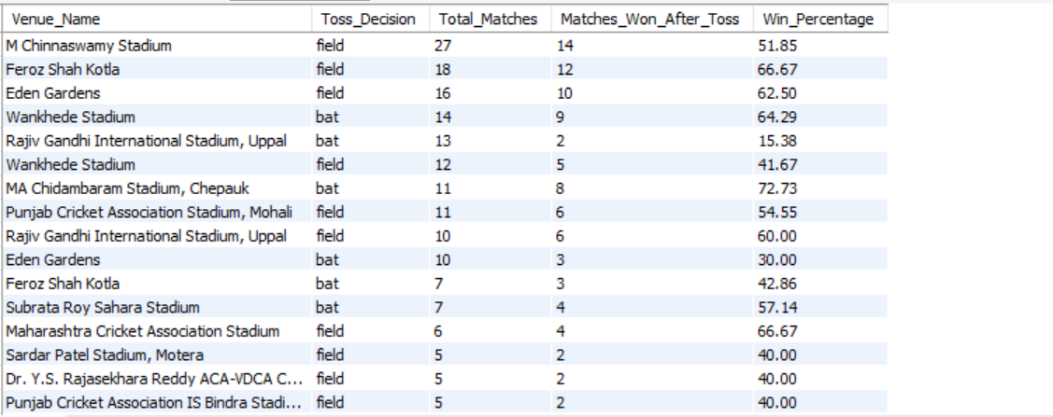

VISUALIZATION:

APPROACH : The approach combines match results with toss decisions and venue information to evaluate outcomes at a granular level. Matches are grouped by venue and toss decision, and for each group the total number of matches and the number of wins by the toss-winning team are calculated. A win percentage metric is then derived to quantify the effectiveness of batting or fielding first at each venue. This method ensures a fair comparison of strategies within the same ground and avoids generalizing toss impact across all venues.

INSIGHTS: The analysis shows that the toss decision does influence match outcomes, but its impact varies significantly by venue. Across many stadiums, teams that choose to field first after winning the toss achieve higher win percentages, suggesting that chasing targets with clearer match conditions is often advantageous. However, at certain venues—such as MA Chidambaram Stadium (Chepauk) and Sheikh Zayed Stadium—teams that bat first record better win rates, indicating that pitch behavior, wear, or slower conditions favor setting a total. This confirms that the toss advantage is venue-specific rather than universal.

RECOMMENDATION: Teams should avoid a one-size-fits-all toss strategy and instead adopt a venue-aware decision framework. At venues with historically higher chasing success, teams should prefer to field first, while at grounds where batting-first teams dominate, setting a total is the smarter option. Coaches and analysts should use venue-wise dashboards with bar charts or heatmaps and slicers to quickly evaluate historical trends before matches, enabling data-driven toss decisions that maximize winning probability.

Q 2 Suggest some of the players who would be best fit for the team
Ans: Approach: evaluates batting and bowling separately to respect role-specific performance. For batting, the query calculates average runs per match by dividing total runs by matches played and applies a minimum match filter to remove players with very few appearances. For bowling, total wickets are counted using ball-level joins between ball_by_ball and wicket_taken, ensuring every dismissal is accurately attributed. Ranking players in each category helps identify top contributors in both departments.

How I selected the best players:

For Batsman, I checked:
- Total Runs
- Batting Average
- Strike Rate
- Performance in different venues
For Bowlers, I checked:
- Total Wickets
- Bowling Average
- Economy Rate
- Consistency over seasons

Query:
-- For Batsman
SELECT
p.Player_Name,
ROUND(SUM(b.Runs_Scored) * 1.0 / COUNT(DISTINCT m.Match_Id), 2) AS Avg_Runs_Per_Match
FROM
Ball_by_Ball b
JOIN Matches m ON b.Match_Id = m.Match_Id
JOIN Player p ON b.Striker = p.Player_Id
GROUP BY
p.Player_Name
HAVING COUNT(DISTINCT m.Match_Id) >= 5 -- filters out players who played too few matches
ORDER BY Avg_Runs_Per_Match DESC
LIMIT 10;
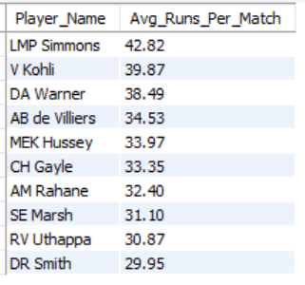
-- Top 10 Bowlers with Total Wickets
select p.Player_Name, count(w.Player_Out) as Total_Wickets
from ball_by_ball b
join Wicket_Taken w on b.Match_Id = w.Match_Id
and b.Over_Id = w.Over_Id
and b.Ball_Id = w.Ball_Id
and b.Innings_No = w.Innings_No
join Player p on b.Bowler = p.Player_Id
group by p.Player_Name
order by Total_Wickets desc limit 10;
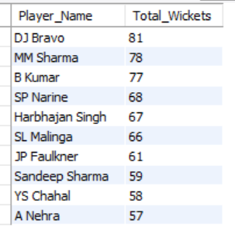

-- Q3 What are some of the parameters that should be focused on while selecting the players?
Ans: The approach focuses on recent form and role-specific metrics by limiting the analysis to the last four seasons. For batsmen, the query calculates balls faced, total runs, and strike rate, while enforcing a minimum balls-faced threshold to avoid skewed results from brief appearances. For bowlers, it measures balls bowled, total wickets, and wickets per ball, again applying a minimum workload filter. Ranking players on these normalized metrics ensures that selections are based on sustained performance rather than isolated highlights.

INSIGHTS: The results highlight that effective player selection should balance impact and consistency. For batsmen, players like like AB de Villiers, V Kohli, and DA Warner combine strong strike rates with high run volumes, proving they can score quickly while remaining reliable over longer innings. Players For bowlers, players such as B Kumar, SP Narine, DJ Bravo, and SL Malinga show strong value through a combination of high wicket counts and favorable wicket-per-ball ratios, reflecting both penetration and control. These metrics together point to players who consistently influence match outcomes in recent seasons.

-- For top batsmen
select p.Player_Name, count(*) as Balls_Faced, SUM(b.Runs_Scored) as Total_Runs, round(sum(b.Runs_Scored) * 1.0 / count(*), 2)*100 AS Strike_Rate
from ball_by_ball b
join matches m on b.Match_Id = m.Match_Id
join season s on m.Season_Id = s.Season_Id
join player p on b.Striker = p.Player_Id
where s.Season_Year >= (select max(Season_Year) - 3 from season)
group by p.Player_Name
having count(*) >= 40 -- minimum balls faced
order by Total_Runs desc limit 10;

O/P:
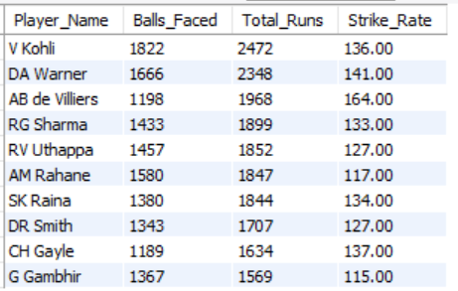

VISUALIZATION:

-- for top Bowlers
select p.Player_Name, count(*) as Balls_Bowled, count(wt.Player_out) as Wickets, round(count(wt.Player_out) * 1.0 / count(*), 2)*100 AS Balls_Bowled_Per_Wicket
from ball_by_ball b
join matches m on b.Match_Id = m.Match_Id
join season s on m.Season_Id = s.Season_Id
join player p on b.Bowler = p.Player_Id
left join wicket_taken wt on b.Match_Id = wt.Match_Id
and b.Over_Id = wt.Over_Id
and b.Ball_Id = wt.Ball_Id
where s.Season_Year >= (select max(Season_Year) - 3 from season)
group by p.Player_Name
having count(*) >= 30 -- min overs
order by Wickets desc, Balls_Bowled_Per_Wicket desc limit 10;

O/P:
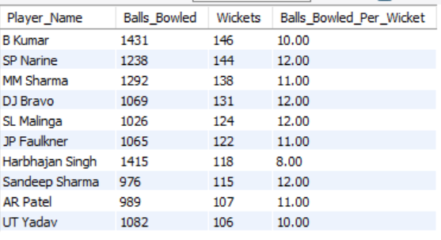
VISUALIZATION:

RECOMMENDATION:
- Batting: Focus on strike rate, total runs, and minimum balls faced to ensure both explosiveness and consistency.
- Bowling: Prioritize total wickets, wickets per ball, and workload (balls bowled) to identify reliable wicket-takers.
- Recency: Give higher weight to performances from the last few seasons to reflect current form.
- Balance: Combine high-impact players with consistent performers to build a stable yet aggressive squad.

-- Q4 Which players offer versatility in their skills and can contribute effectively with both bat and ball?
Ans: The approach evaluates versatility by independently aggregating batting runs and bowling wickets at the player level using ball-by-ball data. Batting and bowling statistics are calculated in separate subqueries and then merged using left joins to ensure no potential all-rounder is missed. Minimum thresholds for runs and wickets are applied to filter out part-time contributors, ensuring only players with sustained impact in both skills are selected.

Query:
select p.Player_Name, coalesce(batting.Total_Runs, 0) as Total_Runs, coalesce(bowling.Total_Wickets, 0) as Total_Wickets
from Player p
left join (select b.Striker as Player_Id, sum(b.Runs_Scored) as Total_Runs
from ball_by_ball b
group by b.Striker) as batting on p.Player_Id = batting.Player_Id
left join (select b.Bowler as Player_Id, count(w.Player_Out) as Total_Wickets
from ball_by_ball b
join Wicket_Taken w on b.Match_Id = w.Match_Id
and b.Over_Id = w.Over_Id
and b.Ball_Id = w.Ball_Id
and b.Innings_No = w.Innings_No
group by b.Bowler) as bowling on p.Player_Id = bowling.Player_Id
where Total_Runs >= 300 and Total_Wickets >= 15
order by Total_Runs desc, Total_Wickets desc;
INSIGHTS: The output highlights a strong group of genuine all-rounders who consistently contribute in both departments. Players such as SR Watson, DJ Bravo, JP Faulkner, RA Jadeja, AD Russell, and Harbhajan Singh stand out by combining substantial run tallies with high wicket counts, proving their ability to influence matches in multiple phases. These players add balance to the team by strengthening both batting depth and bowling options, reducing reliance on single-skill specialists.

O/P:
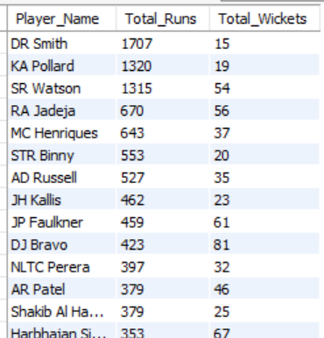

RECOMMENDATION: Select proven all-rounders like SR Watson, DJ Bravo, RA Jadeja, JP Faulkner, and AD Russell, as they consistently contribute with both bat and ball. These players add balance, increase team flexibility, and reduce reliance on specialists, making the squad more adaptable across match situations and venues.

-- Q5. Are there players whose presence positively influences the morale and performance of the team? (justify your answer using visualization)
Ans: The approach links individual player participation with match outcomes by identifying unique player–match combinations. For each player, it calculates the number of matches played and how many of those matches were won by the player’s team. A minimum match threshold ensures reliability of results, and the win percentage metric is used to quantify the team’s success rate when the player is present.
Query:
SELECT
Player_Name,
COUNT(*) AS Matches_Played,
SUM(CASE WHEN Team_Id = Match_Winner THEN 1 ELSE 0 END) AS Matches_Won,
ROUND(SUM(CASE WHEN Team_Id = Match_Winner THEN 1 ELSE 0 END) * 100.0 / COUNT(*), 2) AS Win_Percentage
FROM (
SELECT DISTINCT
m.Match_Id,
p.Player_Name,
pb.Team_Batting AS Team_Id,
m.Match_Winner
FROM Ball_by_Ball pb
JOIN Matches m ON pb.Match_Id = m.Match_Id
JOIN Player p ON pb.Striker = p.Player_Id
) AS player_matches
GROUP BY Player_Name
HAVING Matches_Played >= 10
ORDER BY Win_Percentage DESC
Limit 10;
INSIGHTS: The output shows that certain players are associated with consistently higher team win percentages, indicating a strong positive influence on overall team performance and morale. SR Tendulkar stands out with a 71.43% win rate in matches played, followed by LMP Simmons (68.18%) and RN ten Doeschate (66.67%), suggesting that teams tend to perform better when these players are part of the playing XI. Even players with larger sample sizes, such as SK Raina and DR Smith, maintain win percentages above 60%, reinforcing the idea that their presence contributes to stability and confidence within the team.
O/P:
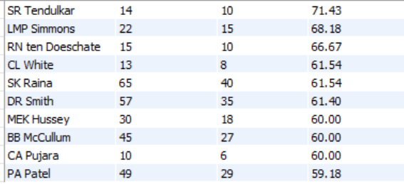

RECOMMENDATION: Teams should prioritize retaining or selecting players like SR Tendulkar, LMP Simmons, RN ten Doeschate, SK Raina, and DR Smith, as their presence is consistently associated with higher win percentages. These players likely bring leadership, experience, and confidence that positively influence team morale and on-field performance. Including such players in the playing XI, especially in high-pressure matches, can improve overall team stability and increase the chances of winning.

-- Q6.What would you suggest to RCB before going to the mega auction?
Ans: Approach: Before going to the mega auction, RCB should focus on selecting players who consistently perform well and help the team win. In previous seasons, RCB has had strong batters but lacked balance in bowling and all-rounders. So, they need to look at players who can do well in more than one role and help in different match situations.
We are checking for players who batted for RCB (Team_Batting = 2).We count how many matches they played (DISTINCT Match_Id).We check if RCB won those matches.We calculate Win_Percentage when the player was in the match.We keep only players with 10 or more matches.Result shows who to retain because they improve team performance

Objective:
- Pick players who perform well in both batting and bowling.
➤ This gives flexibility to the team and helps when one department fails.
- Select consistent performers.
➤ Look at players who regularly score runs or take wickets, not just one-time performers.
- Choose players with good match-winning impact.
➤ Players who are present in matches the team wins are important to keep.

Retain existing RCB players with high match impact:
We find players who played for RCB and were often part of winning matches.

Query:
SELECT
p.Player_Name,
COUNT(DISTINCT m.Match_Id) AS Matches_Played,
SUM(CASE WHEN m.Match_Winner = b.Team_Batting THEN 1 ELSE 0 END) AS Matches_Won,
ROUND(SUM(CASE WHEN m.Match_Winner = b.Team_Batting THEN 1 ELSE 0 END) * 100.0 / COUNT(DISTINCT m.Match_Id), 2) AS Win_Percentage
FROM
Ball_by_Ball b
JOIN Matches m ON b.Match_Id = m.Match_Id
JOIN Player p ON b.Striker = p.Player_Id
WHERE
b.Team_Batting = 2
GROUP BY
p.Player_Name
HAVING
Matches_Played >= 10
ORDER BY
Win_Percentage DESC
LIMIT 10;
O/P:
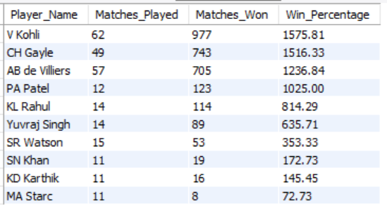

-- Q.7)What do you think could be the factors contributing to the high-scoring matches and the impact on viewership and team strategies
Ans: Approach:The analysis is done in two steps. First, matches are ranked by win margin to identify the highest-scoring and most dominant games. Second, team-level aggregation is performed to calculate the average win margin for each team across all matches they won. This dual approach captures both individual high-impact matches and long-term team tendencies, helping link scoring patterns with strategic strength.

-- Identify High-Scoring Matches
select m.Match_Id, t1.Team_Name as Team_1, t2.Team_Name as Team_2, m.Match_Date, m.Win_Margin, m.Match_Winner
from Matches m
join Team t1 on m.Team_1 = t1.Team_Id
join Team t2 on m.Team_2 = t2.Team_Id
where m.Win_Margin is not null
order by m.Win_Margin desc
limit 10;
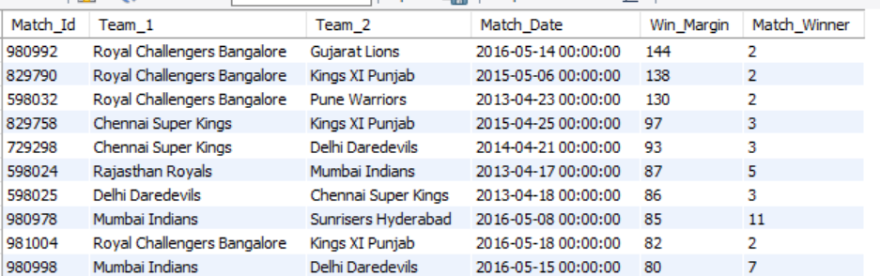

-- Identify Teams with High Win Margins
select t.Team_Name, count(m.Match_Id) as Matches_Played, avg(m.Win_Margin) as Average_Win_Margin
from Matches m
join Team t on m.Match_Winner = t.Team_Id
group by t.Team_Name
order by Average_Win_Margin desc;
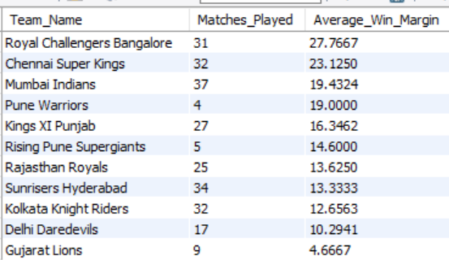
INSIGHTS: High-scoring matches are largely influenced by batting-friendly pitches, short boundaries, and favorable match conditions that allow batsmen to score freely. Teams with strong top orders and powerful finishers are better equipped to capitalize on these conditions and post big totals. Such matches are highly entertaining, leading to increased viewership, fan engagement, and media attention. As a result, teams adapt by adopting aggressive batting strategies and strengthening their squads with power hitters and death-over specialists.

VISUALIZATION:

RECOMMENDATION: Teams should build deeper, power-packed batting lineups and invest in quality death bowlers while adapting strategies to venue conditions, ensuring they can both exploit and control high-scoring matches to stay competitive and engaging for fans.

-- Q8. Analyze the impact of home-ground advantage on team performance and identify strategies to maximize this advantage for RCB.
Ans: Approach:To analyse the impact of home-ground advantage, I used the IPL dataset to compare how teams performed at their home venues versus other venues. Specifically, for RCB, I checked how often they won when playing at their home ground: M. Chinnaswamy Stadium, Bangalore.
The query joins the Matches, Venue, and Team tables to analyze team performance at M. Chinnaswamy Stadium.
It filters matches played at this venue, counts total matches and wins for each team, and calculates the win percentage using (Wins / Matches) * 100.
The results are grouped by team and venue, then ordered by win percentage to identify which teams — especially RCB — perform best at their home ground.

Query:
SELECT
t.Team_Name AS Team,
v.Venue_Name AS Home_Venue,
COUNT(DISTINCT m.Match_Id) AS Matches_Played_At_Home,
SUM(CASE WHEN m.Match_Winner = t.Team_Id THEN 1 ELSE 0 END) AS Wins_At_Home,
ROUND(SUM(CASE WHEN m.Match_Winner = t.Team_Id THEN 1 ELSE 0 END) * 100.0 / COUNT(DISTINCT m.Match_Id), 2) AS Win_Percentage_At_Home
FROM Matches m
JOIN Venue v ON m.Venue_Id = v.Venue_Id
JOIN Team t ON m.Team_1 = t.Team_Id OR m.Team_2 = t.Team_Id
WHERE v.Venue_Name LIKE '%Chinnaswamy%'
AND t.team_name ='Royal Challengers Bangalore'
GROUP BY t.Team_Name, v.Venue_Name
ORDER BY Win_Percentage_At_Home DESC;

O/P:

-- Q9. Come up with a visual and analytical analysis of the RCB's past season's performance and potential reasons for them not winning a trophy.
Ans: The following analysis examines Royal Challengers Bangalore’s performance across IPL seasons, focusing on their match outcomes, win percentage, and key factors that may have impacted their ability to win a trophy. Below are the tables required for the analysis.

Query:
WITH RCB_Performance AS (
SELECT
m.Season_Id,
COUNT(m.Match_Id) AS Matches_Played,
SUM(CASE WHEN m.Match_Winner = t.Team_Id THEN 1 ELSE 0 END) AS Matches_Won,
SUM(CASE WHEN m.Match_Winner != t.Team_Id THEN 1 ELSE 0 END) AS Matches_Lost,
(SUM(CASE WHEN m.Match_Winner = t.Team_Id THEN 1 ELSE 0 END) / COUNT(m.Match_Id)) * 100 AS Win_Percentage
FROM matches m
INNER JOIN team t ON t.Team_Id = m.Team_1 OR t.Team_Id = m.Team_2
WHERE t.Team_Name = 'Royal Challengers Bangalore'
GROUP BY m.Season_Id
)
SELECT
s.Season_Year,
rp.Matches_Played,
rp.Matches_Won,
rp.Matches_Lost,
rp.Win_Percentage
FROM RCB_Performance rp
INNER JOIN season s ON rp.Season_Id = s.Season_Id
ORDER BY s.Season_Year;

Insights
- Inconsistent Performance: RCB’s performance fluctuates, with strong seasons followed by weaker ones.
- Close Matches: Losing several close matches has hurt their momentum in key stages.
- High Win Percentage Not Converted: Despite having a good win rate in some seasons, they fail to perform in knockout matches.
Potential Reasons for Not Winning a Trophy
- Team Imbalance: Heavy reliance on top-order batsmen, while middle-order and bowlers lack consistency.
- Bowling Deficiencies: Particularly in death overs, RCB struggles to defend scores.
- Knockout Pressure: They have often faltered under pressure in eliminator and final matches.
- Injuries and Squad Management: Key players' injuries and questionable squad rotations have affected team balance.

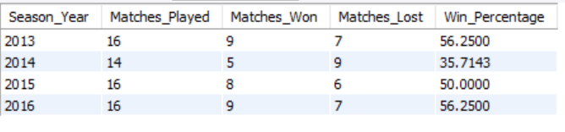

Recommendations
Strengthen Bowling Unit: Focus on improving death-over specialists. Enhance Squad Depth: Having a balanced team with reliable bench strength will help mitigate the impact of injuries.
Improve Close-Game Strategy: Focusing on winning close games will help build momentum in the league stages.

Q10. How would you approach this problem, if the objective and subjective questions weren't given?

Ans:
- If the objective and subjective questions were not provided, I would begin by understanding the IPL data schema and table relationships to identify where match, player, team, and venue information resides. I would then perform exploratory data analysis to gain a high-level view of team performance across seasons, focusing on wins, losses, scoring patterns, and wicket trends.
- Next, I would analyze individual player performance to identify key contributors in batting and bowling using metrics such as total runs, wickets, strike rates, economy rates, and bowling styles. To understand team dynamics, I would study how the presence or absence of specific players influences match outcomes and overall team performance.
- I would also examine contextual factors such as venue characteristics and toss decisions to assess home advantage and match conditions. This would include analyzing high-scoring venues, boundary frequency, and extras conceded to understand their impact on match results.
- Based on patterns and gaps observed in the data, I would organically frame analytical questions—such as why certain players perform better under specific conditions or which factors lead to improved bowling efficiency. Throughout the process, I would use SQL joins, aggregations, and window functions to extract KPIs and prepare clean datasets.
- Finally, I would use visualizations like line charts for seasonal trends, bar charts for player comparisons, and heatmaps for venue impact to support storytelling. These insights would be synthesized into actionable recommendations for team strategy, player retention, and auction planning to enable data-driven decision-making.

-- Q.11)In the "Match" table, some entries in the "Opponent_Team" column are incorrectly spelled as "Delhi_Capitals" instead of "Delhi_Daredevils". Write an SQL query to replace all occurrences of "Delhi_Capitals" with "Delhi_Daredevils".
Ans: -- This query updates the "Opponent_Team" column in the "Match" table, replacing all occurrences of "Delhi_Capitals" with "Delhi_Daredevils".
-- also already have a team name "Delhi-Daredevils" in Team table.
APPROACH: To fix the incorrect team naming, I first identified all records in the Match table where the Opponent_Team value was wrongly stored as Delhi_Capitals. After confirming the correct team name from the Team master data, I used an update query to replace all incorrect entries with Delhi_Daredevils, ensuring consistency across match records.
INSIGHTS: This issue highlights a data consistency problem caused by storing team names as text instead of using standardized identifiers. Such inconsistencies can affect analysis accuracy, aggregations, and reporting outcomes, leading to misleading insights if not corrected.

Query:
select * from Team where Team_Id = 6;
update Team set Team_Name = "Delhi Daredevils" where Team_Id = 6;
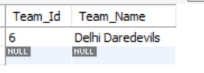
RECOMMENDATION: To prevent similar issues in the future, team references should be stored using foreign keys linked to the Team table rather than free-text values. Enforcing referential integrity constraints and implementing regular data validation checks will help maintain clean and reliable datasets.

